**Tenancy sustainment team user guide**

**Logging in to Clearing House**

Check that you are using the correct user name, the format is first name.surname@clearinghouse.org. For example, jane.doe@clearinghouse.org

Password resets can be requested from the CH login page at <https://clearinghouse.force.com/login>

Accounts that have been inactive for 6 months or more are automatically locked. To reactivate a locked account contact the Clearing House Helpdesk by telephone 020 38566008 or email [ch@mungos.org](mailto:ch@mungos.org)

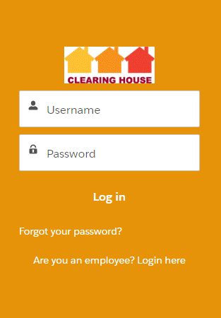

**Finding the Clearing House Library**

When you log in, you will see a tab called More. Click this and you’ll see Clearing House Library as one of the options. When you click on it the library when open in a new tab.

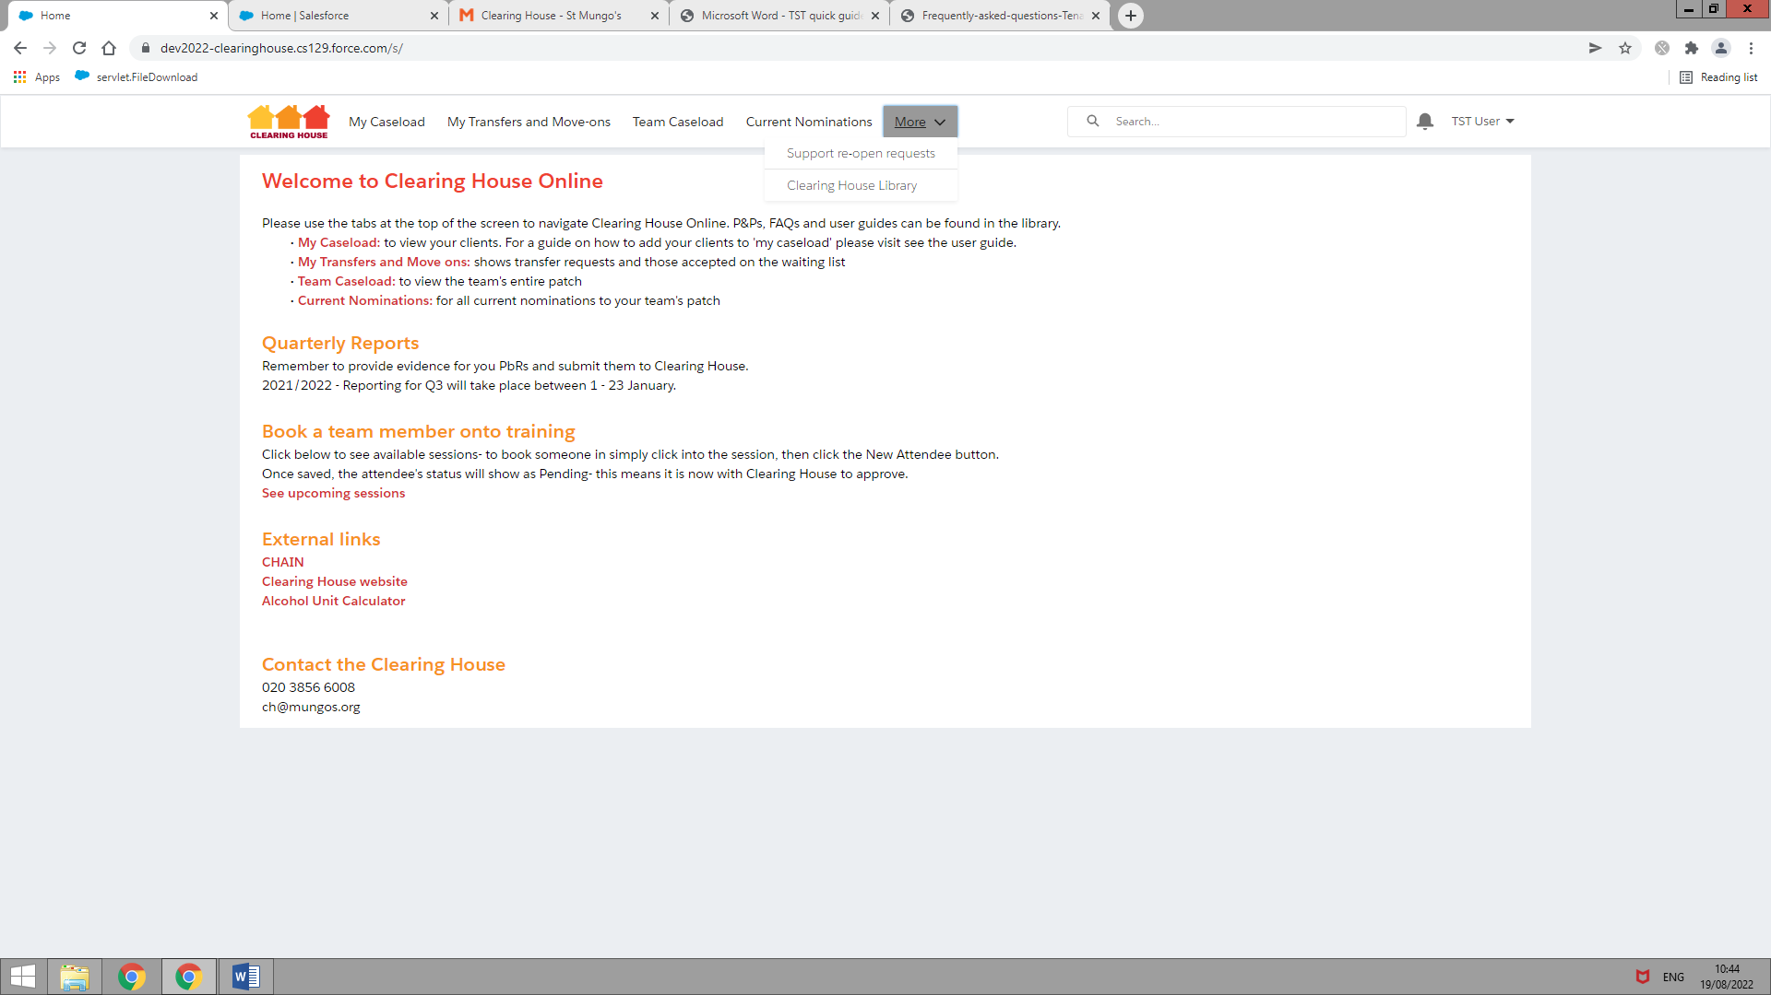

You can also find the Clearing House Library at <https://www.mungos.org/our-services/clearing-house/#user_guides>

If you can’t find something you are looking for, or need to speak with a member of the team, please contact us using the Contact Information on the Home Page.

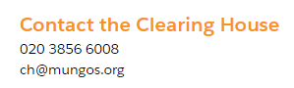

**Returning to the Home Page**

Simply click on the Clearing House logo:

**Making edits to forms**

Any time you would like to edit a form, simply hover over the right hand side of the information you wish to change, where you can see a faint grey icon:



Once you hover over it, it will turn to a darker shade:



You can then click to add/edit the information:

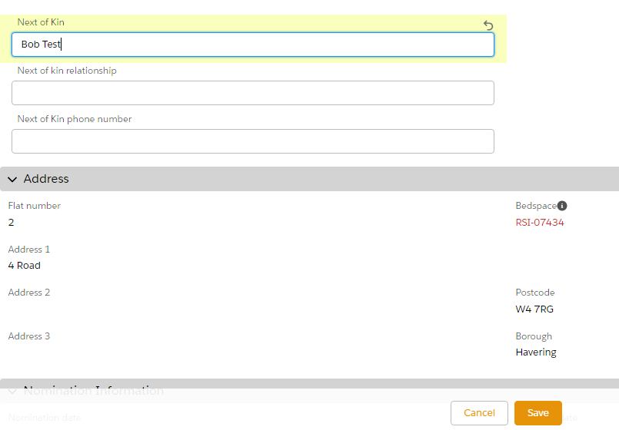

And click Save to finish:



Alternatively, you can simply double click on the information you wish to edit, and you’ll then see the edit box appear:



If you’re searching for someone’s name to select them on a page (e.g. assigning yourself as the TST worker), please **do not** click on the New Contact option:

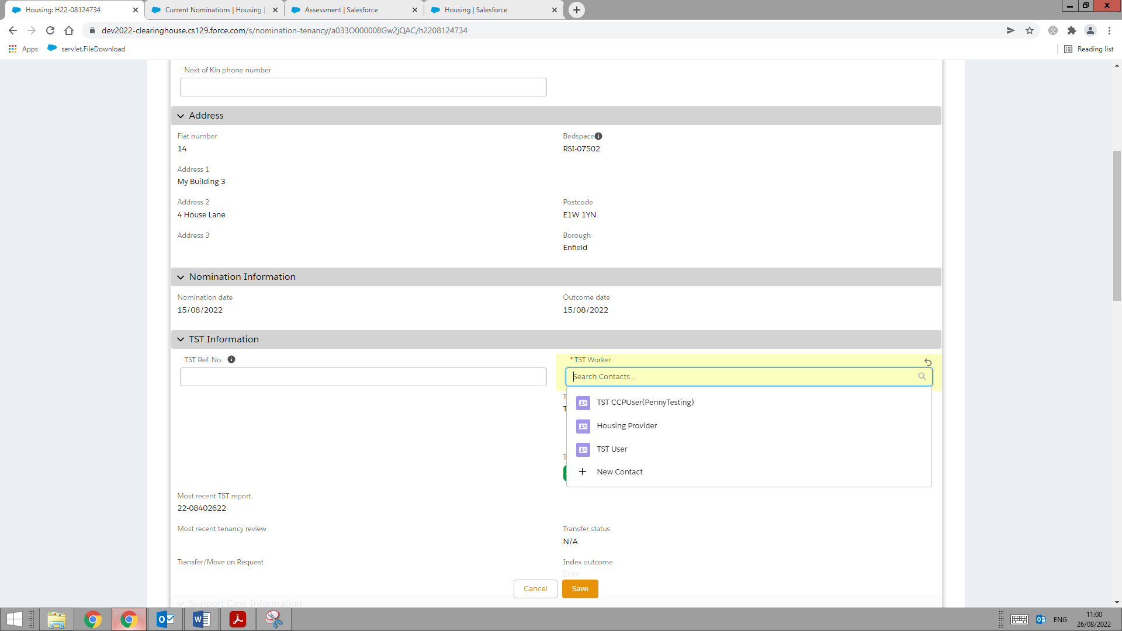

**DO NOT USE THIS**

A red star means this field is mandatory and you won’t be able to save without having completed it:

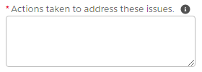

If you see an icon like this on the right - 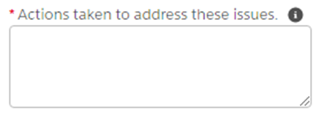 -it will show help text when you hover on it:

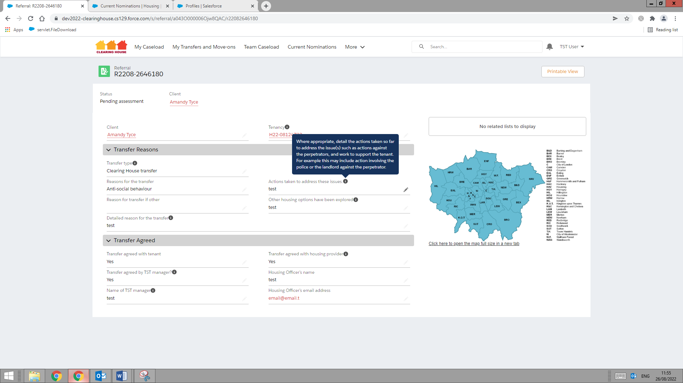

If you’re using Chrome as your internet browser and are typing into a text box that you would like to make bigger, you can use the icon in the bottom right to drag the text box to be larger- just click then drag:



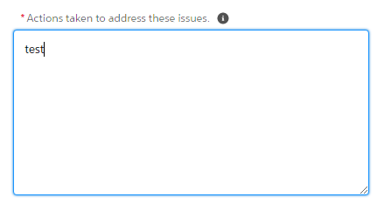

When you need to enter a date, you can either type it in using dd/mm/yyyy format (e.g. 02/10/2022) or use the date picker that appears to select the appropriate date:

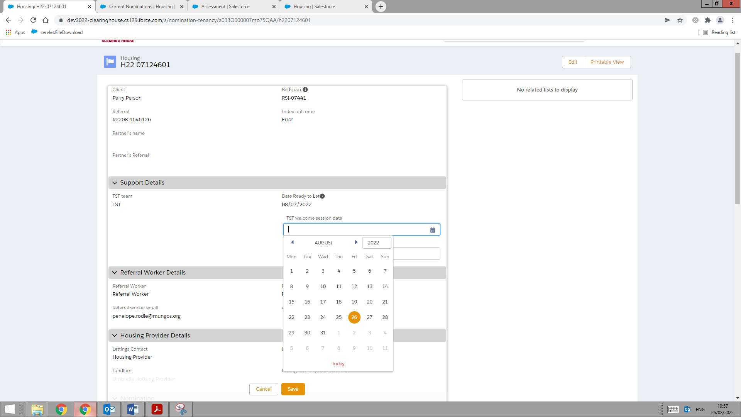

**Finding a tab**

If you ever can’t find a tab referenced in this, you may find it in a tab called More:

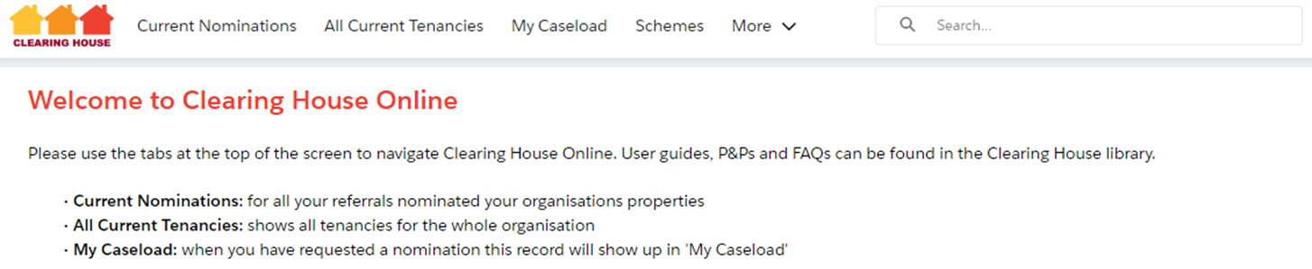

**Adding your clients to ‘My Caseload’**

You will see that you have two caseload tabs in the top bar- My Caseload and Team Caseload. If a client isn’t appearing in My Caseload, click Team Caseload and all of your team’s clients will show:

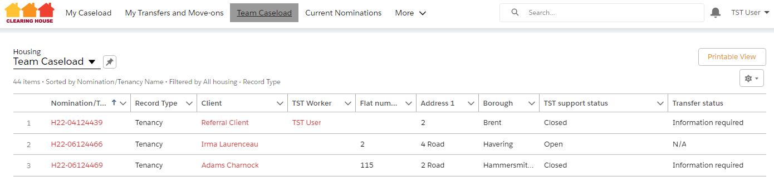

1

3

2

You can sort the results by any of the headers- e.g. if you click on the Client header (1) it will sort the client names alphabetically so you can find the person you’re looking for more easily.

Click into the tenancy page by clicking on the red number starting with H (2).

Scroll down to the TST Information section and enter your name in the TST worker field, then click Save.

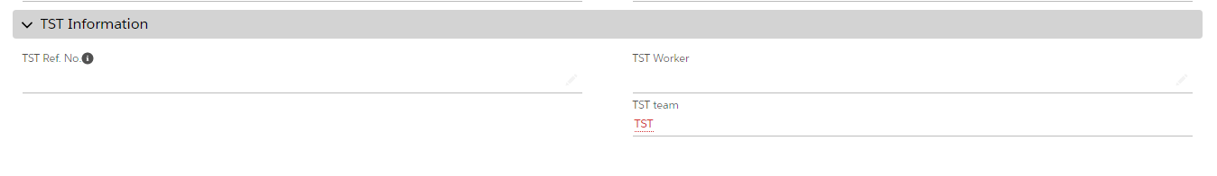

If there’s lot of clients in the Team Caseload list and you’re struggling the find the right person, you can search for the client’s name in the search bar (3). You can also search by their CHAIN number of date of birth, if you have this information. Then follow the steps above to add yourself as the client’s TST worker.

Do the same for all the clients you work with. You will then be able to find them easily by using the ‘My Caseload’ tab.

**Tenancy end reports and Support case closures:**

Go to the client’s housing record (HXXXXXX) and you will see buttons on the top right:

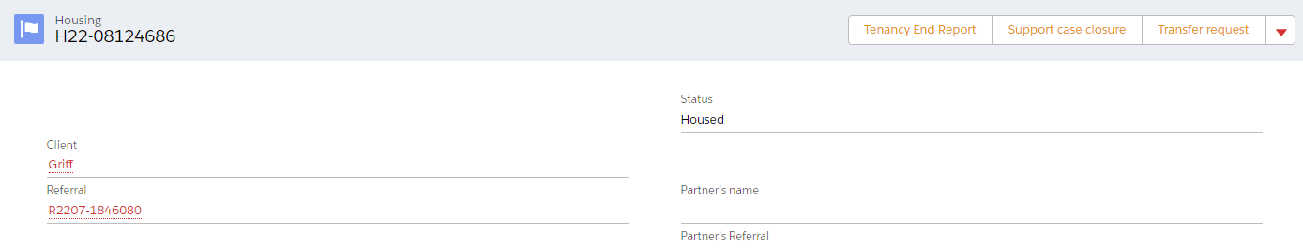

Click the relevant button, fill out the information and click Save.

**Tenancy reviews**

You will receive an email saying that a tenancy review is due. Follow the link in that email to go directly to the tenancy review record.

If you don’t have an email, go to client’s housing record (HXXXXXX) and scroll down to the Assessments section:

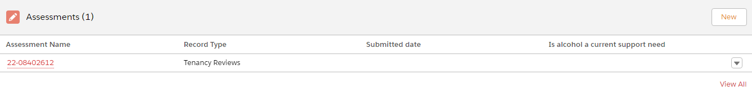

1

2

You may see more than one Tenancy review here, but ones you have completed already will have a submitted date (1), so look for a review with no date, like in this example. Click into the review by clicking the red link under Assessment Name (2).

Then use the Update tenancy review button to complete the review:

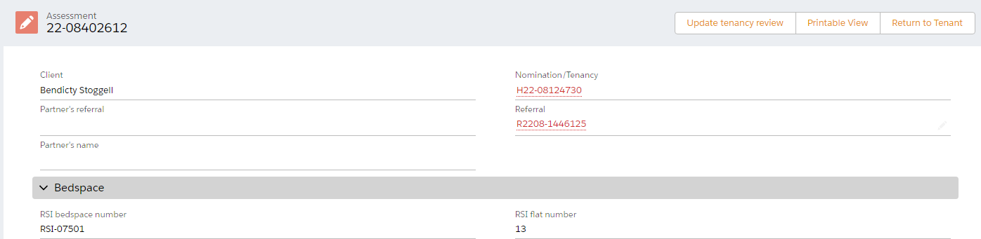

**Create a transfer request**

Go to the client’s housing record (HXXXXXX) and you will see the Transfer request button on the top right:



Fill out all the information and click Save.

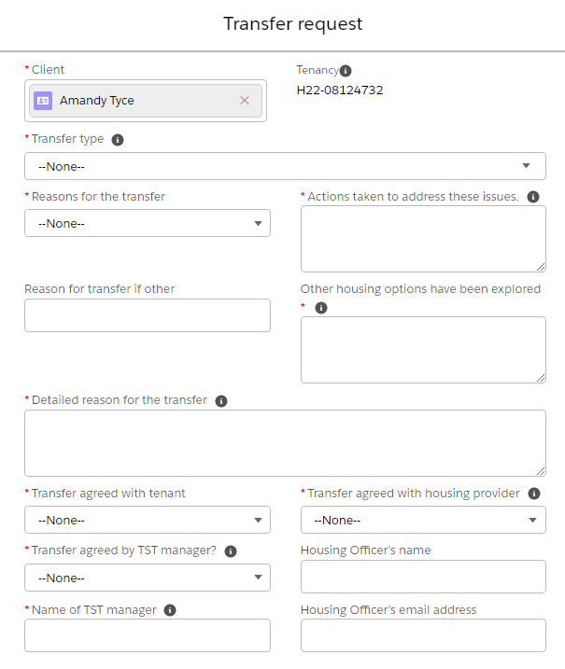

Clearing House will then assess whether a client re-referral to the waiting list will be possible.

**Create and submit a Move on Programme referral**

Go to the client’s housing record (HXXXXXX) and you will see the Move on Programme button on the top right when you click the dropdown arrow:

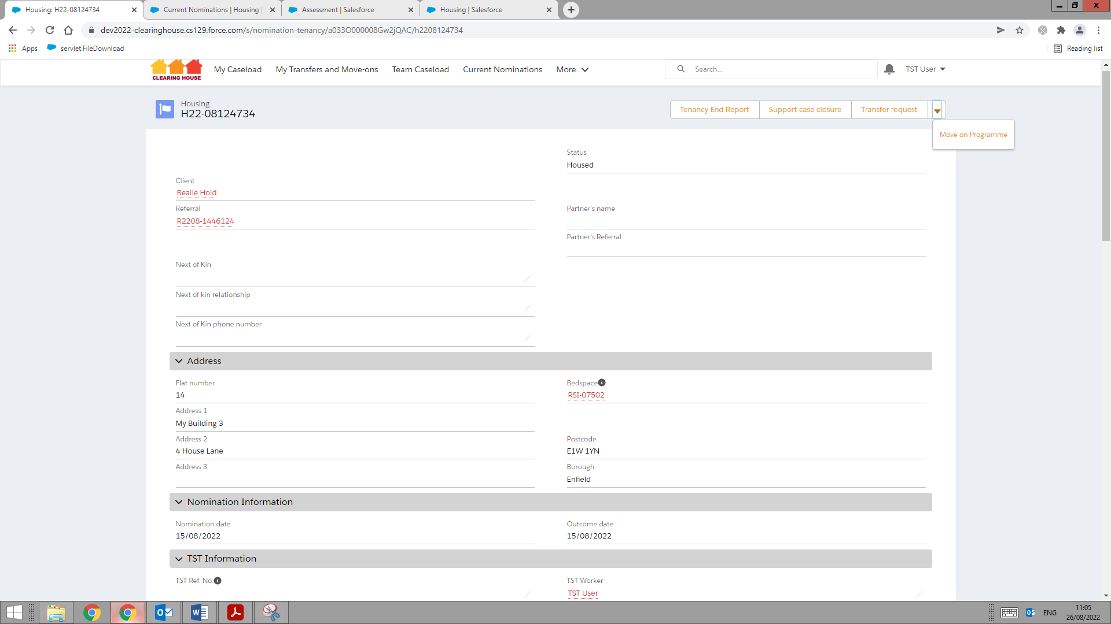

Click this and fill out the information in the pop up box that appears, then click Save.

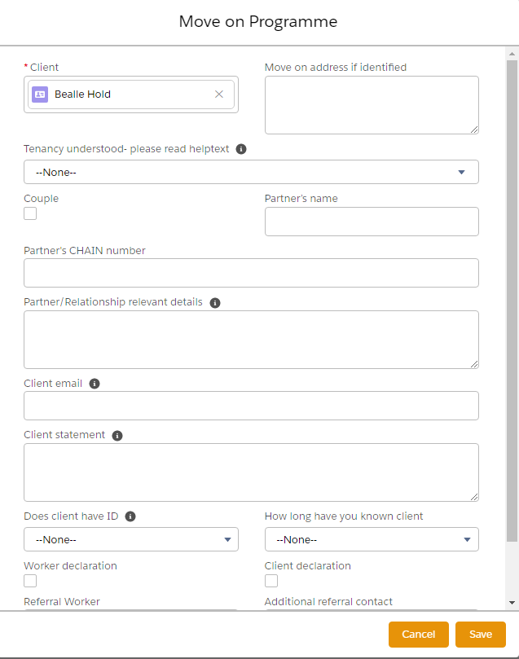

You now need to navigate to the referral you’ve just started in order to complete and submit it to Clearing House.

Scroll down to the TST section of the tenancy record and you’ll see a Transfer/Move on Request link:

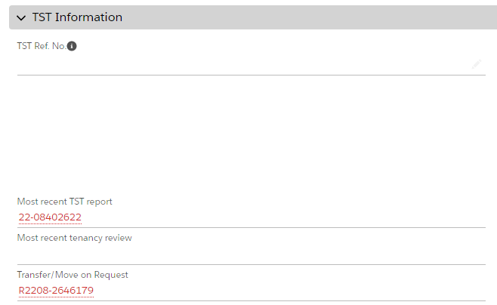

Click into this link and you’ll be directed to the referral to complete.

At this point, if you need to go away and back to the referral later, you can do so – just click the My Transfers and Move-ons tab to find the referral.

Otherwise, follow the instructions on the right on the referral:

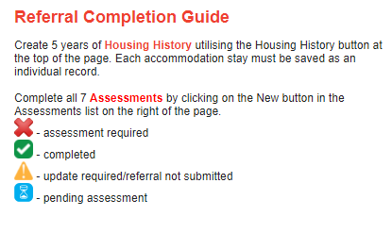

Since this client is moving on, we’ll already have their housing history, so there’s no need to create these records to submit the referral.

**Assessments**

Here’s where you create the assessments:

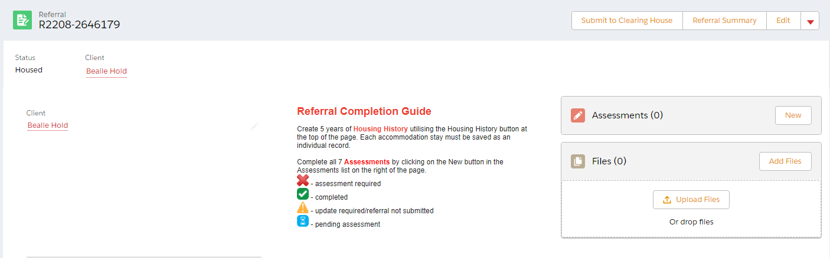

Ignore the TST Support Case Closure and Tenancy End Report options, and work your way through numbers 1 to 7.

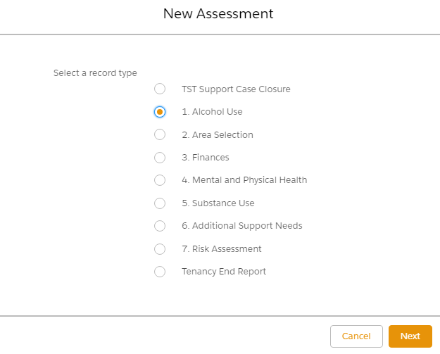

Once you’ve created an assessment you’ll see that its icon in the Referral Status section has changed:

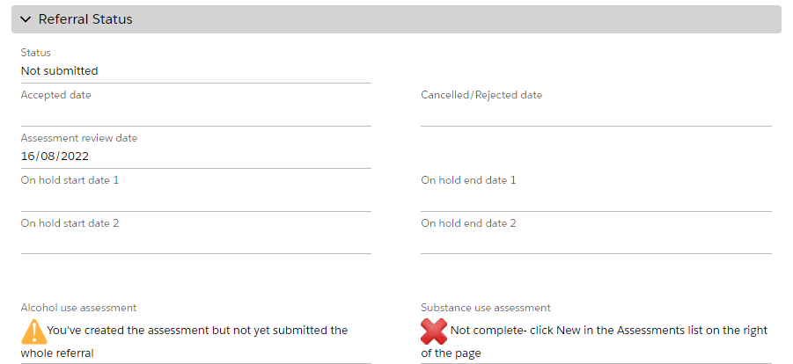

If you need to edit or add extra information to the assessment before you’re ready to submit the referral, click into the red link under the name of the assessment:

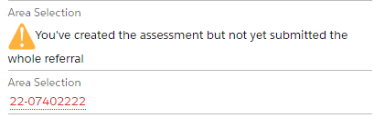

Once you’re on the assessment page, just double click on the answers you wish to update, this will then change to an editable box. Make the changes and click Save.

**Client Privacy Notice**

Download the privacy notice via the blue link at the bottom of the referral:

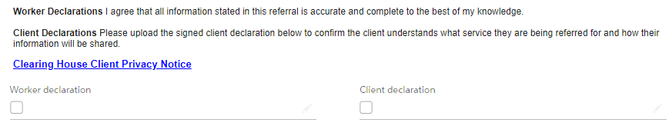

Once the client has signed it, upload the signed client privacy notice in the files section on the right of the screen:

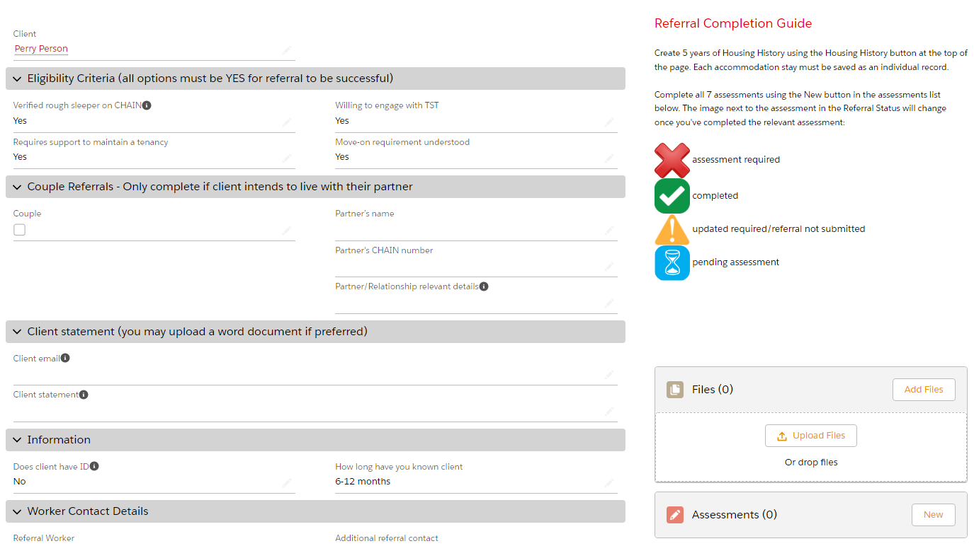

Then click the Worker declaration and Client declaration tickboxes and click Save.

**What is the client statement?**

Clients are encouraged to write a personal statement expressing why they want to be referred to Clearing House and what they hope to get out of the service. This information is used in the referral assessment process.

**Submitting the referral**

If you’re ready to submit the referral, click the Submit to Clearing House button on the top of the page:



You’ll either receive a message on screen reminding you of something you haven’t added to the referral yet (e.g. current housing or one of the assessments) or a note that the referral has now been submitted.

Once the Clearing House team have reviewed the referral, you will receive an email advising that the referral has been accepted, not accepted or requesting more information.

**Current nominations**

When a client is nominated to a property which falls within your patch, a notification email will be sent to the address you have provided. The email will hold a link to the system where you can log in and click the ‘current nominations’ tab (if you can’t see the tab, click the More tab and it will be one of the options there). The referral e.g. R1234-567890, will take you to the client and support needs information. The client housing record e.g. H12-34567 will take you to the nomination, including information about property and contact details for landlord and referrer:

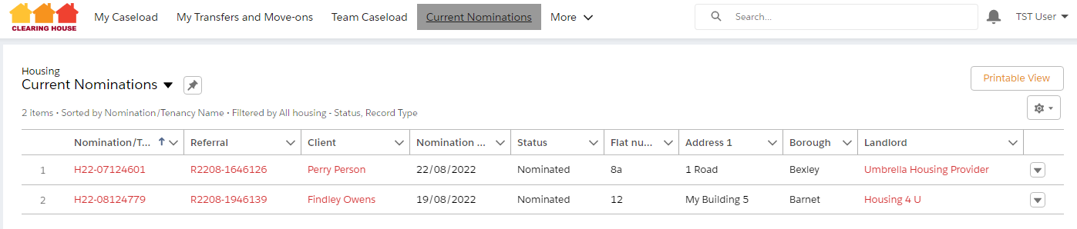

Assessment information on each referral can be accessed using the red link by each assessment:

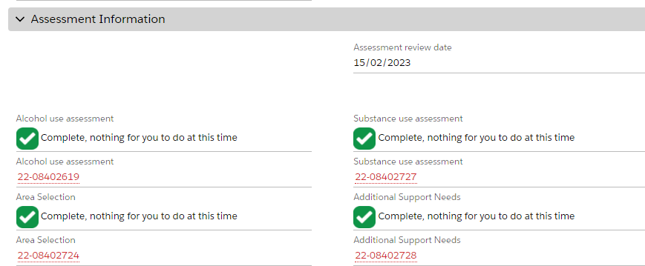

**Responding to Support Case re-open requests**

Go to the support re-open requests tab (if you can’t see it click More and it will be one of the options there):

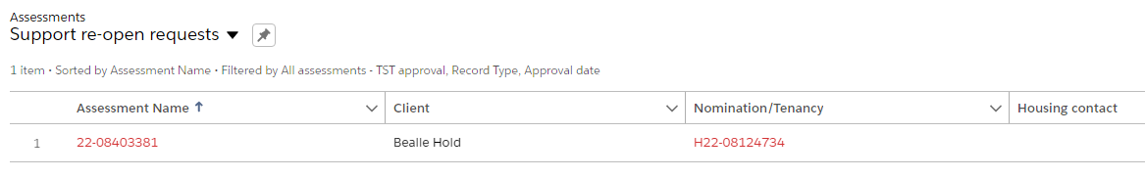

Click into the Assessment name and you’ll be taken to the request:

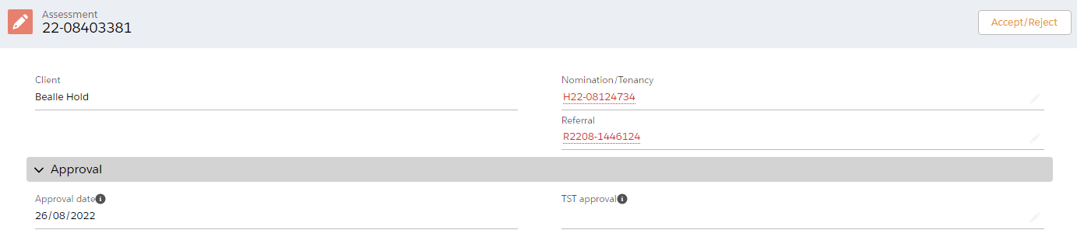

Then click Accept/Reject and then Finish:

